Tensor Flow
- Open source
- Developed by Google
- Building, training and deploy ML models
- Especially focused Deep learning.

Tensor flow types
- TensorFlow.js for browser based ML
- TensorFlow Lite mobile apps
- TensofFlow Extended (TFX) for production pipelines

Use cases
- Smart compose in gmail
- Google translate
- Google lens

Data Structure of a Tensor
- It is multi-dimensional array with a single data type
  - Scalar 0D tensor
  - Vector 1D tensor
  - Matrix 2D tensor
  - Higher dimensions 3D+, images, videos etc
- ML compatibility
  - Most ML algorithms expect data in matrix form (2 D tensors), where
    - Row = data points
    - Columns – features

Assignment https://www.tensorflow.org/api_docs/python/tf

Keras
- It is high level API that runs on top of deep learning
- Easy to use syntax for building the models quickly
- Complex neural networks can be created with only few lines of code

Building a neural network in keras
Steps
- Import libraries
- Define the model
  - Sequential API – stack layers linearly
- Compile the model
  - modile.compile
- train the model
  - model.fit
- evaluate the model
  - model.evaluate
  - loss, accuracy

key features of Keras
- pre-built layers Dense, Conv2D, Dropout, Batch normalization
- optimizes Adam, SGD etc.,
- loss function MSE (mean squared error), binary cross entropy, categorical cross entropy
- callbacks early stopping, model checkpoint : these helps to avoid overfitting

pipeline: Define Compile Train Evaluate

Epoch
One epoch means the network has processed all training samples once.
- Each epoch gives the model an opportunity to update weights and biases using gradient descent
- Risk – more epochs can improve learning but may risk overfitting

Batch size
- No.of training examples used in one iteration
- For ex batch size = 64, meaning the model updates weights after every 64 samples
- Smaller batch size more frequent updates noisy
- Larger batch size stable updates, requires more memory

Dense layer fully connected layer all neurons connected to previous layer
Formula: Parameters = (Input neurons * output neurons) + biases
Ex first hidden layer (784 * 128) + 128 =
- Trainable parameters weights and biases updated during training
- Non-trainable parameters fixed during training ex : dropout masks

Overfitting
- Model learns exact patterns of training data – fails to generalie
  - Indication s – training accuracy very high, validation accuracy low.
- Solution
  - Use dropout , regularization, or early stopping
  - Collect more training data

Underfitting
- Model fails to capture major patterns in the data
  - Indications
    - Low training accuracy
    - Insufficient data
- Sol
  - Increase model complexity
  - Add more features / neurons
  - Train longer / more epochs.

Dropouts in neural network

It is a regularization technique
It helps to reduce overfitting - ,making models more generalize to unseen data
It helps break co-adaptations of neurons by randomly deactivating some neurons during training

Co-adaptation – relying too much on each other
- Some neurons learn to only work well when other neurons are active
- They develop dependencies
- This reduces the ability to generalize

Layer-1
O O O O
Layer-2 O O

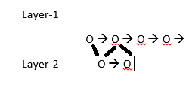

With dropout
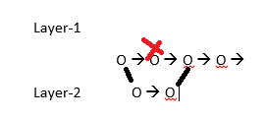

Batch normalization
It is a technique to improve neural network training
It helps stabilize and accelerate the training activation

- Neural networks can produce large activations in hidden layers – varying activations can cause unstable training
Normalization
  - Reduce the no.of epochs need for training
  - Prevent network from getting stuck
  - Decouple the interactions between weight matrices across layers

Consider feedforward equations for a 4-layer network
x 1 = sigma ( W1.x + b1), x2 = sigma (W2.x1+b2)…
output of each layer depends on previous layer weights
during back propagation, weights are updated independently but unstable activations may hinder learning
so batch normalization addresses this by normalizing layer outputs for each mini-batch

how - ?
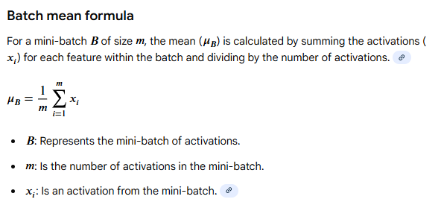

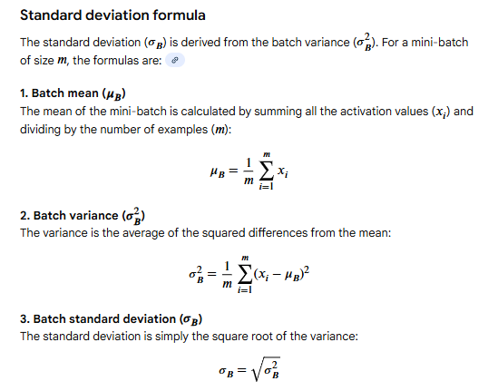

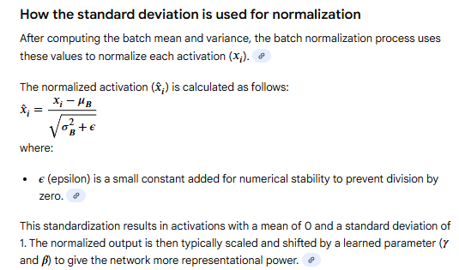

Ex
Housing data model
First hidden layer has 2 neurons and batch size=6
For neuron 1
- Compute 6 outputs x1,x2,x3….x6
- Compute mean (u1) and std deviation(sigma 1)
- Normalize outputs : x1 = (x1-u1)/sigma1
Repeat for neuron 2
Above step repeats

